# Brainstorm

**TIP**

You can select a sticky note and hit the pencil [switch to sketch] icon to start drawing!

### Before you collaborate

#### A little bit of preparation goes a long way with this session. Here’s what you need to do to get going.

##### 10 minutes

**1**

### Define your problem statement

#### What problem are you trying to solve? Frame your problem as a How Might We statement. This will be the focus of your brainstorm.

##### 5 minutes

**2**

### Brainstorm

#### Write down any ideas that come to mind that address your problem statement.

##### 10 minutes

**3**

### Group ideas

#### Take turns sharing your ideas while clustering similar or related notes as you go. In the last 10 minutes, give each cluster a sentence-like label. If a cluster is bigger than six sticky notes, try and see if you and break it up into smaller sub-groups.

##### 20 minutes

**4**

### Prioritize

#### Your team should all be on the same page about what's important moving forward. Place your ideas on this grid to determine which ideas are important and which are feasible.

**20 minutes**

### After you collaborate

You can export the mural as an image or pdf to share with members of your company who might find it helpful.

**Quick add-ons**

# & idea prioritization

**PROBLEM**

**How might we [your problem statement]?**

**A Team gathering**

Define who should participate in the session and send an

**RAJKIRAN S S**

**TIP**

Add customizable tags to sticky notes to make it easier to find, browse, organize, and categorize important ideas as themes within your mural.

**SRIGOVINDH**

###### KAMALESUWARAN D

**GURURAJAN**

###### Share the mural

Use this template in your own brainstorming sessions so your team can unleash their imagination and start shaping concepts even if you're not sitting in the same room.

invite. Share relevant information or pre-work ahead.

###### Set the goal

Think about the problem you'll be focusing on solving in the brainstorming session.

###### Learn how to use the facilitation tools

User Feedback

Customer Privacy

Solution to Customer

FIlteration based on services

Providing Chatbox

Providing services on time

Asking for Rating

Customer Satisfaction

Tracking of Services

Deals with Problem quickly

Filtration Based on details

Listen Carefully to the queries

Allocating Agent

Deals with problem quickly

Providing service details

Live chatbox

Email Nodification

Customer Queries

Customer Satisfaction

Agent details

Notifying customer

Checking customer needs

Solution for Customer issues

Live chat

Security

Providing Chatbox

CUSTOMER

Solution for

Deals with

Providing

**Share a view link** to the mural with stakeholders to keep them in the loop about the outcomes of the session.

**B Export the mural**

Export a copy of the mural as a PNG or PDF to attach to emails, include in slides, or save in your drive.

**10 minutes** to prepare

**1 hour** to collaborate

**2-8 people** recommended

**C**

Use the Facilitation Superpowers to run a happy and productive session.

[**Open article**](https://support.mural.co/en/articles/2113740-facilitation-superpowers)

**Key rules of brainstorming**

Providing the service on time

customer needs

Solution to Customer

Notifying

Customer

CUSTOMER FEEDBACK

Providing

Chatbox

problem quickly

Customer

Queries

service on Time

### Keep moving forward

###### Strategy blueprint

Define the components of a new idea or strategy.

###### [Open the template](https://app.mural.co/template/e95f612a-f72a-4772-bc48-545aaa04e0c9/984865a6-0a96-4472-a48d-47639307b3ca)

To run an smooth and productive session

## CHATBOX

###### Customer experience journey map

Deals with the problem quickly

Stay in topic. Defer judgment.

Encourage wild ideas. Listen to others.

Live chat

Providing chatbox

**Importance**

If each of these

Understand customer needs, motivations, and obstacles for an experience.

[**Open the template**](https://app.mural.co/template/b7114010-3a67-4d63-a51d-6f2cedc9633f/c1b465ab-57af-4624-8faf-ebb312edc0eb)

Go for volume. If possible, be visual.

## FEEDBACKS

tasks could get

done without any difficulty or cost, which would have the most positive impact?

**Strengths, weaknesses, opportunities & threats**

Identify strengths, weaknesses, opportunities, and threats (SWOT) to develop a plan.

|  |  |
| --- | --- |
|  |  |
|  |  |

###### [Open the template](https://app.mural.co/template/6a062671-89ee-4b76-9409-2603d8b098be/ca270343-1d54-4952-9d8c-fbc303ffd0f2)

Customer Satisfaction

User Feedback

Asking for Rating

## INFORMATION

Listen

TIP

Participants can use their cursors to point at where sticky notes should go on the grid. The facilitator can

[**Share template feedback**](https://muralco.typeform.com/to/CiqaHVat?typeform-source=app.mural.co)

Email

Nodification

Carefully to

the queries

confirm the spot by using the laser pointer holding the **H key** on the keyboard.

## SECURITY

Security

Customer Privacy

## SERVICES

###### [Share template feedback](https://muralco.typeform.com/to/CiqaHVat?typeform-source=app.mural.co)

Providing services on time

FIlteration based on services

Tracking of Services

Allocating Agent

Providing service details

Agent details

Customer Queries

**Feasibility**

Regardless of their importance, which tasks are more feasible than others? (Cost, time, effort, complexity, etc.)

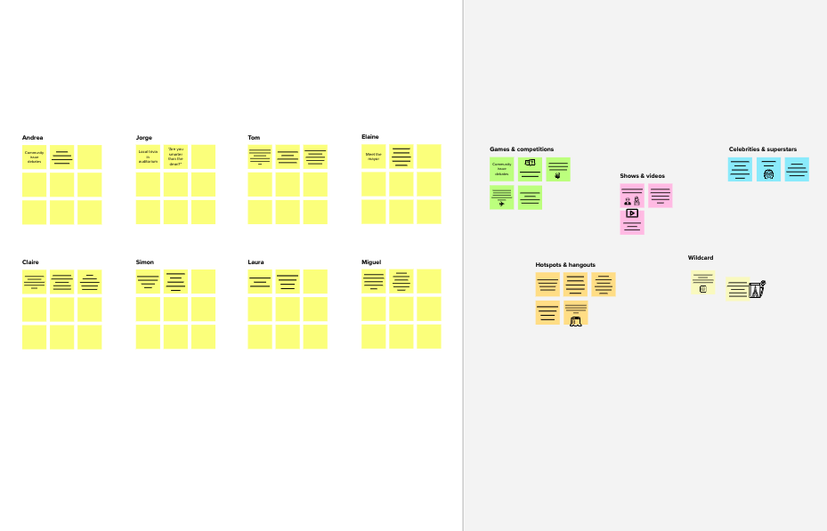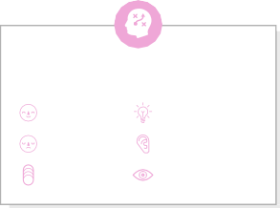

**Template**

**Need some inspiration?**

See a finished version of this template to kickstart your work.

[**Open example**](https://app.mural.co/template/e5a93b7b-49f2-48c9-afd7-a635d860eba6/93f1b98d-b2d2-4695-8e85-7e9c0d2fd9b9)